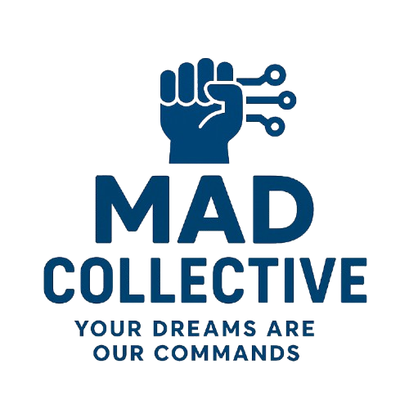

**Business Proposal for CareemNow + Loyverse POS Integration**

Prepared for: Dough Works

Prepared by: MAD Collective

Date: October 2025

# 1. Executive Summary

Dough Works is expanding its digital operations and requires a seamless integration between CareemNow and Loyverse POS to improve order management, reduce manual work, and ensure real-time synchronization across all sales channels. MAD Collective proposes a tailored middleware solution designed for reliability, speed, and scalability.

# 2. Business Objectives

• Centralize order management across delivery platforms and POS.  
• Automate inventory synchronization and stock updates.  
• Enhance operational visibility through real-time dashboards.  
• Reduce manual data entry and human errors.  
• Improve customer satisfaction through faster order processing.

# 3. Proposed Solution

MAD Collective will develop a custom Laravel-based integration middleware that connects CareemNow and Loyverse POS. This system will automate the flow of orders, inventory, and receipts while providing Dough Works with a clear, centralized dashboard to monitor operations.

# 4. Key Benefits

• Real-time synchronization between CareemNow and Loyverse.  
• Centralized order and inventory management.  
• Reduced administrative workload.  
• Scalable architecture supporting future integrations.  
• Secure and compliant data handling with API encryption and monitoring.

# 5. Implementation Roadmap

The project will be executed over a 12-Days timeline divided into key phases:  
• Phase 1–2: System setup, database design, and API connections.  
• Phase 3–4: Core feature development and testing.  
• Phase 5–6: Deployment, training, and go-live monitoring.

# 6. Investment & Timeline

The integration will be delivered within 12 Days. Pricing will depend on final scope and API access agreements. MAD Collective offers flexible payment milestones aligned with development phases.

|  |  |  |
| --- | --- | --- |
| Options | Scope | Fees |
| Option 1 | Integration Careem with Loyverse POS in one direction Careem 🡺 Loyverse | 500 USD |
| Option 2 | Integration Careem with Loyverse POS in two direction Careem 🡺 Loyverse  Loyverse 🡺 Careem | 750 USD |

**Price terms and conditions

* **Prices are IN USD And Don’t Including any Local TAX (VAT or Income)**
* **Prices don’t include Server or Hosting Fees**
* **Full payment after the integration is done and deployed to your Server**

# 7. Conclusion

With this integration, Dough Works will enhance operational efficiency, improve customer satisfaction, and position itself for scalable digital growth. MAD Collective is ready to partner with Dough Works to bring this vision to life.